Recommendation System For Movies And Products

TRAINING PROJECT REPORT

Submitted by

Shivam Kumar Tiwari (23BCS12755)

in partial fulfillment for the award of the degree of

BACHELOR OF ENGINEERING

IN

COMPUTER SCIENCE ENGINEERING

Chandigarh University

JUNE-2025

BONAFIDE CERTIFICATE

Certified that this project report “Recommendation System For Movies And Products” is the bonafide work of “Shivam Kumar Tiwari (23BCS12755)”who carried out the project work under my/our supervision.

SIGNATURE

Dr. Sandeep Singh Kang

ASSOCIATE DIRECTOR
(CSE-3rd Year)
SIGNATURE

Er. Roop Sharma

SUPERVISOR
(CSE-3rd Year)

Submitted for the project viva-voce examination held on

INTERNAL EXAMINER EXTERNAL EXAMINER

TABLE OF CONTENTS
List of Figures i
List of Tables ii
Abstract iii
Chapter 1. Introduction 8-12
Client Need Identification of Contemporary Issue 8
Identification of Problem 9
Identification of Task 10
Timeline 11
Organization of the Report 12
Chapter 2.Literature Review Background Study 13-19
Timeline of the Reported Problem 13
Proposed Solutions 14
Bibliometric Analysis 15
Review Summary 16
Problem Definition 17
Goals/Objectives 18
Chapter 3. Design Flow/Process 20-27
Evaluation & Selection of Specifications/Features 20
Design Constraints 21
Analysis and Feature Finalization Subject to Constraints 23
Design Flow 24
Design Selection 25
Implementation Plan/Methodology 26
Chapter 4. Result Analysis And Validation 28-32
Implementation of Solution 28
Output Screenshots 29
Chapter 5. Conclusion & Future Work 33-41
Conclusion 33
Future Work 38
References 42

List of Figures

Figure 1.1: Project timeline using gantt chart 11
Figure 3.1: Flowchart 28
Figure 4.1: Home Page – Recommendation Type Selection 34
Figure 4.2: Movies Page – Filter Form and Results 34
Figure 4.3: Products Page – Category Filtering 35
Figure 4.4: Surprise Me – Random Result Display 36
Figure 4.5: RecoBox on Mobile Device 37

List of Tables

Table 1.1: Tasks to identify problems 10
Table 2.1: Evolution of Recommendation Systems and Motivation Behind RecoBox...13
Table 2.2: Traditional Approaches 14
Table 2.3: Modern Solutions 14
Table 2.4: Adopted Solution for this Project 15
Table 2.5: Comparative Bibliometric Analysis 16
Table 2.6: Defined Objectives of the RecoBox Recommendation System……………..19
Table 3.1: Features Evaluated from Literature & Existing Solutions 21
Table 3.2: Design Constraints Considered in RecoBox Development………………….23
Table 3.3: Finalization of Features Based on Design Constraints 24
Table 3.3: Comparison between Design Flow 1 and Design Flow 2 27

ABSTRACT

In a world increasingly reliant on digital services for everyday tasks, personalized recommendations have become an integral part of enhancing user experience in e-commerce and entertainment platforms. The project titled "RecoBox: A Smart Recommendation System for Movies and Products" aims to deliver a web-based solution that provides intelligent recommendations based on user-selected filters such as genre, category, and age range, ultimately enhancing user engagement and satisfaction.
This project was developed as part of an industrial training initiative with the goal of applying theoretical knowledge of software development, C# programming, and full-stack web technologies in a real-world scenario. The system is built using ASP.NET Core MVC framework, utilizing C# for backend logic and Razor pages for dynamic content rendering. The frontend is styled with HTML, CSS, and Bootstrap, providing a responsive and aesthetically pleasing user interface.
The application is structured into three core features:
Movie Recommendation: Users can filter by genre (e.g., Action, Comedy) and age category (e.g., New, Old) to receive top-rated suggestions.
Product Recommendation: Similar functionality for products based on type and relevance.
Surprise Me: A randomized feature that offers spontaneous suggestions for user discovery.
Each feature is powered by predefined, structured data models that simulate real recommendation logic. The system processes user input via GET requests and dynamically renders personalized suggestions using Razor Views, thereby ensuring a fast and interactive experience without requiring backend reloading or database dependency.
The development period (June 2025) focused on ensuring modular code structure, user-friendly

design, and consistent output formatting. The project tackled multiple engineering challenges including form handling across multiple pages, responsive card-based layouts, and efficient state management through query parameters. Design considerations such as sticky footers, hover effects, Google Fonts integration, and mobile responsiveness were prioritized to ensure both usability and visual appeal.
The RecoBox project successfully demonstrates the integration of server-side logic, frontend responsiveness, and conditional content rendering, offering a practical blueprint for beginner-level recommendation engines. Future extensions could include user authentication, machine learning–based recommendation logic, and database integration for dynamic content updates.
RecoBox stands as a clean, modular, and scalable web application that showcases the potential of ASP.NET Core MVC in building smart, interactive platforms for personalized content delivery.

CHAPTER 1.
INTRODUCTION

1.1. Client Need Identification of Relevant Contemporary Issue

In the modern digital ecosystem, users are overwhelmed with choices, whether browsing movies on streaming platforms or shopping for products online. While these platforms provide a vast array of content and items, the lack of personalization can result in decision fatigue, leading to a frustrating user experience.
This is where RecoBox steps in — a smart recommendation system tailored to help users quickly find relevant content by filtering based on their interests, such as movie genres, product categories, and age relevance (new vs. old). The need for such a system has grown significantly due to:
Increasing digital consumption trends
User demand for customized experiences
Widespread use of recommender systems by leading platforms like Netflix, Amazon, and Flipkart
However, building such intelligent systems usually involves complex data science and machine learning pipelines, which are not always feasible or necessary for basic, user-guided filtering systems. Therefore, RecoBox focuses on delivering a lightweight, structured, and rule-based recommendation system, suitable for educational purposes and prototype-level demonstrations.
From a training and academic perspective, the project addresses contemporary themes in:
Web development using ASP.NET Core MVC
Human-centered design in user interface development
Feature-based content filtering logic
It reflects both practical engineering challenges (like form handling, UI responsiveness, GET vs POST
request logic) and usability concerns that are critical in building production-ready web tools.

1.2. Identification of Problem

In the era of digital overload, users are often confronted with an abundance of choices across entertainment and e-commerce platforms. While algorithms can offer personalized recommendations, most of them are either hidden behind complex machine learning models or require access to sensitive user data and behavioral patterns.
This creates a significant gap for:
Users who prefer quick, interest-based filtering over deep personalization
Developers or learners seeking to build a recommendation engine without advanced AI/ML
Organizations or academic environments where user privacy, simplicity, and transparency are preferred
Moreover, existing systems often lack a clean, intuitive, and flexible interface that allows users to explicitly select what they want — such as filtering movies based on genre and age group or browsing products by type and time relevance. These limitations point to a need for a simple yet effective solution that:
Allows users to get meaningful suggestions with minimal input
Is modular and customizable for different domains (movies, products, etc.)
Does not rely on external APIs, heavy datasets, or user login systems
Thus, the core problem identified is the lack of a lightweight, user-driven, and flexible recommendation system that operates without the need for data mining or AI but still delivers relevant and personalized suggestions in a web environment.

1.3. Identification of Tasks
To successfully develop the RecoBox web application, the project was broken down into clearly defined tasks. Each task focused on solving a specific aspect of the problem, ranging from system planning to frontend design and recommendation logic implementation. The goal was to follow a modular development approach that allows for easy testing, debugging, and future scalability.

Task Category | Description
Requirement Analysis | Identify the need for a lightweight recommendation system. Define user inputs such as genre, category, and age filters. Clarify the project's scope (movies, products, surprise feature) and expected outputs.
Design
  Design the layout and user interface using Razor Views, Bootstrap, and HTML/CSS. Ensure an intuitive experience with responsive design and aesthetic elements like card views, Google Fonts, and hover effects.
Development | Implement backend logic in ASP.NET Core MVC using C#. Configure controllers to handle GET-based input and route to proper views. Integrate Razor syntax for dynamic rendering of filtered movie and product recommendations.
Testing
  Perform end-to-end testing of user input forms, filtering logic, and output results. Test responsiveness, accuracy of filtering, and overall flow across different devices and screen sizes.
Deployment | Deploy the project locally for demonstration purposes. Ensure routing, static assets, and form actions work smoothly in a live localhost environment.
Documentation | Create the final project report as per university guidelines. Include all essential sections like abstract, introduction, design methodology, screenshots, and future scope. Prepare a user manual for step-by-step usage.

Table 1.1: Tasks to identify problems

1.4. Timeline

Below is the proposed timeline of the project phases distributed over the training duration:

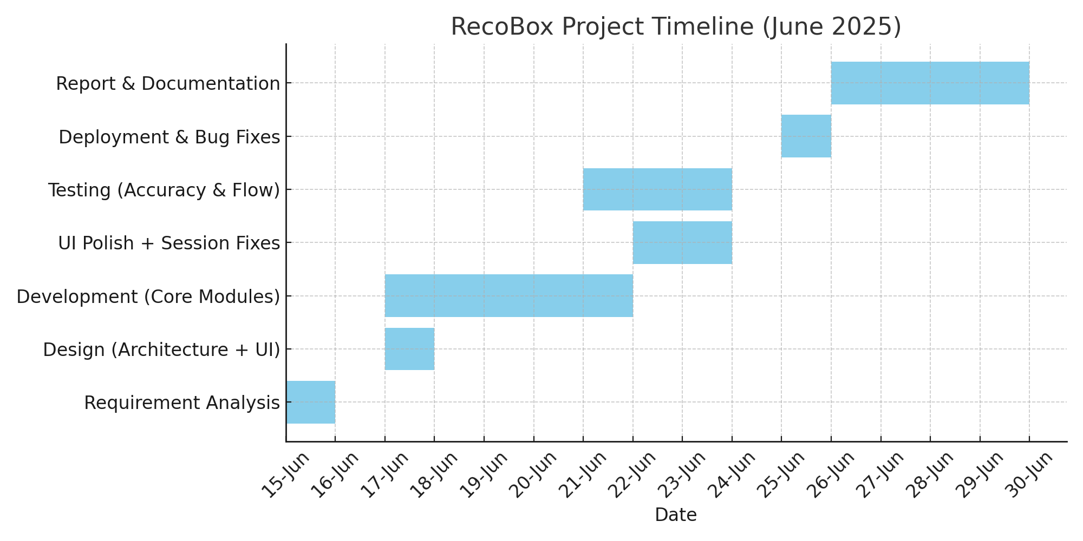

Figure 1.1: Project timeline using gantt chart

1.5. Organization of the Report

This report is structured into five chapters to present a comprehensive overview of the project “Recommendation System For Movies And Products” Each chapter focuses on a specific phase of the project lifecycle:
- Chapter 1: Introduction
This chapter introduces the need for a user-friendly recommendation system. It outlines the problem, defines the project objectives, identifies tasks, and presents a timeline for the project.

- Chapter 2: Literature Review / Background Study
A study of previous solutions, related technologies, and design approaches relevant to recommendation systems. It includes bibliometric analysis, summary of findings, and a formal definition of the problem along with project goals.
Chapter 3: Design Flow / Process
This chapter presents the design considerations, selected features, constraints, and alternative design options. It also explains the chosen solution architecture and the methodology used for implementation.
- Chapter 4: Result Analysis and Validation
Describes the implementation outcomes, includes screenshots of the working system, testing methodology, and analysis of results. It validates whether the objectives were achieved successfully.
- Chapter 5: Conclusions and Future Work
Summarizes the achievements of the project, identifies any deviations from the expected outcomes, and proposes future enhancements or directions to extend the functionality of RecoBox..

CHAPTER 2.
LITERATURE REVIEW/ BACKGROUND STUDY

2.1. Timeline of the Reported Problem

The need for effective recommendation systems has steadily increased with the rise of digital content and e-commerce platforms. While early recommendation engines focused on basic filtering, modern systems are powered by complex algorithms that require substantial data and resources.
However, lightweight, user-driven systems still hold high value in educational tools, privacy-focused platforms, and fast prototyping environments. RecoBox addresses this niche by offering a web-based recommendation tool using filter-based logic instead of AI/ML, making it accessible and easy to implement for learners and developers alike.
Below is a timeline showcasing the evolution of recommendation systems and the motivation behind creating RecoBox::

Year | Event / Development
2003 | Amazon popularizes collaborative filtering for product recommendations using user behavior and purchase history.
2007 | Netflix Prize competition boosts research in recommender algorithms using big data.
2012 | Content-based filtering gains popularity with personalized feeds on YouTube, Spotify, and others.
2015 | Lightweight recommendation engines begin appearing in academic projects with basic rule-based filtering.
2018 | Rise of frameworks like ASP.NET Core and Django makes it easier to create modular, scalable web applications.
2020 | COVID-19 accelerates the need for smarter digital tools as online content consumption surges
2023 | Increasing privacy concerns shift interest towards non-AI, no-login tools with user-driven logic.
2025 | RecoBox developed to demonstrate a practical, user-guided recommendation engine using ASP.NET Core MVC without relying on machine learning or user data collection.

Table 2.1: Evolution of Recommendation Systems and Motivation Behind RecoBox

2.2. Proposed Solutions

The rise of online content and shopping platforms has driven the evolution of recommendation systems. These systems aim to help users find relevant content quickly by predicting their preferences. Various solutions have been proposed over the years — from basic rule-based filtering to complex AI-driven personalization.
Below is an overview of different types of recommendation techniques, including the approach adopted in the RecoBox project, which emphasizes usability, simplicity, and modular design over heavy computation.

Traditional Approaches:

Solution | Description | Limitations
Manual Categorization | Items are manually sorted into genres or categories and shown in bulk (e.g., movie lists by genre). | No personalization, overwhelming for users, static experience.
Hardcoded Recommendations | Static “Top Picks” or “Popular Now” sections on websites. | Doesn’t adapt to user preferences or filter inputs.
Keyword Filtering | Allows filtering based on title keywords or tags. | Inefficient and inaccurate if not well tagged.

Table 2.2: Traditional Approaches

Modern Solutions:

Solution | Description | Benefits | Challenges
Collaborative Filtering | Suggests items based on other users with similar preferences. | Dynamic, data-driven, scalable. | Requires large user data and historical logs.
Content-Based Filtering | Recommends similar items based on user’s selected content attributes (genre, category). | Personalized and doesn’t require user data sharing. | May lead to repetitive suggestions (“filter bubble”).
Hybrid Models | Combine collaborative and content-based methods. | High accuracy, diversity in suggestions. | Complex to implement, dependent on ML models.

Table 2.3: Modern Solutions

Adopted Solution for This Project:

Given the academic context, simplicity requirement, and the absence of large user datasets, RecoBox adopts a user-driven filtering-based system. This lightweight approach provides relevant results using selected filters without any need for AI or user tracking.

Component | Tool/Technology Used | Purpose
Frontend | Razor Views + Bootstrap | Collects user input via dropdowns and displays card-style results.
Backend | ASP.NET Core MVC (C#) | Handles logic for GET-based filtering, data flow, and routing.
Recommendation Logic | Rule-based Filtering | Matches selected genre/category + age group to suggest results.
Randomizer Feature | C# Random Generator | Used for the “Surprise Me” option to display random top-rated content.
Data Storage | In-code Models (No DB) | Static predefined data for movies/products. Easily extendable.

Table 2.4: Adopted Solution for this Project

2.3. Bibliometric Analysis

This bibliometric analysis presents a comparative overview of popular recommendation system approaches, tools, and frameworks from both academic research and real-world platforms. The focus is on evaluating their key features, effectiveness, and drawbacks when applied in different contexts — ranging from commercial-scale platforms to lightweight educational tools.
The analysis references materials from IEEE Xplore, Google Scholar, SpringerLink, and documentation from platforms like Netflix Tech Blog, Amazon Science, and open-source GitHub repositories..

Technology / Method | Key Features | Effectiveness | Drawbacks
Collaborative Filtering | Recommends based on similar users’ behavior and preferences. | High personalization; effective on platforms with large user bases (e.g., Amazon, Netflix). | Requires large datasets; cold-start problem; privacy concerns.
Content-Based Filtering | Recommends items with similar attributes to those previously selected. | Easy to implement; does not need user-to-user data; good for niche items. | Limited diversity in recommendations (filter bubble).
Hybrid Models | Combine collaborative and content-based methods. | Most accurate; balances relevance and diversity. | Complex logic; high resource requirement; usually ML-based.
Rule-Based Filtering (User Input Driven) | Uses predefined filters (genre, category, etc.) to give recommendations. | Simple, interpretable, lightweight; good for educational/demo apps. | No personalization; requires manual categorization of items.
Machine Learning Models (e.g., SVD, DeepRec) | Use trained models to predict user preferences based on patterns. | Very high accuracy in large-scale systems. | High complexity; requires labeled data and computation resources.
ASP.NET Core MVC (Web Framework) | Modern framework for developing modular, responsive, and scalable web apps. | Clean architecture; supports Razor views, form handling, session control. | Not a recommendation-specific library — logic must be built manually.

Table 2.5: Comparative Bibliometric Analysis

2.4. Review Summary

The literature review and bibliometric analysis revealed a diverse spectrum of recommendation approaches, ranging from complex machine learning algorithms to lightweight, rule-based systems. The analysis of existing methods highlighted that while collaborative filtering and hybrid models are highly effective in large-scale platforms, they are often unsuitable for small-scale or educational projects due to their dependence on:
- Large datasets
- Continuous user interaction and tracking
- High computational infrastructure
In contrast, rule-based filtering systems — where users explicitly select what they are looking for — remain highly relevant in scenarios where:
- The dataset is relatively small
- The application is a prototype, demonstration tool, or academic submission
- Transparency, simplicity, and user control are prioritized over personalization
This aligns directly with the objectives of the RecoBox project, where:
- The goal was to implement a modular, interpretable system
- No user login or tracking was required
- Predefined filters (e.g., genre, category, age) could serve user needs effectively
- The system could be deployed without reliance on external APIs or machine learning models
Thus, the review confirms that RecoBox's architecture—centered around user-guided, rule-based filtering—is not only valid but optimal for its intended purpose. It strikes a balance between usability and technical feasibility, serving as a solid baseline for further enhancements such as database integration or AI-driven personalization in future versions..

2.5. Problem Definition
In today’s digital landscape, users are frequently overwhelmed by the sheer volume of content available across platforms, whether they are looking for a movie to watch or a product to purchase. Although many advanced recommendation systems exist, they are often:
- Resource-intensive to build and maintain,
- Dependent on large-scale user behavior data,
- Complex and opaque in how they generate results.
These characteristics make them unfit for educational projects, quick prototypes, or privacy-sensitive applications where transparency and simplicity are important. Moreover, novice developers and students often find it difficult to implement machine learning–based recommenders without significant background knowledge or large datasets.
Given these limitations, the problem identified is the lack of an easy-to-use, lightweight, and modular recommendation system that:
Allows users to guide recommendations using simple filters,
- Can be implemented without ML or external APIs,
- Offers a clean, responsive user interface for interaction,
- Can be easily extended or customized to support multiple content types (e.g., movies, products).
Hence, the project aims to develop RecoBox — a web-based application that solves this problem through:
- Rule-based filtering logic (user input-driven),
- Static yet structured datasets,
- ASP.NET Core MVC for web architecture,
- Clear categorization and modular code.
This well-scoped problem serves as a perfect opportunity to demonstrate core web development, filtering logic, and UI design skills in a structured academic setting.

2.6. Goals/Objectives

The primary goal of the RecoBox project is to design and develop a simple, modular, and user-driven recommendation system that delivers relevant movie or product suggestions based on predefined filters. This goal reflects the need for an accessible, privacy-conscious, and non-AI-based solution suitable for educational and prototype-level applications.
To achieve this goal, the following specific objectives were defined:

Objective | Description
1. Design an intuitive UI | Build a clean and responsive web interface using Razor Views and Bootstrap to enable easy user interaction.
2. Implement a rule-based filtering system | Allow users to select filters like genre, category, and age group to retrieve relevant recommendations.
3. Create modular and maintainable backend logic | Develop backend controllers in ASP.NET Core MVC to handle input routing and logic separation.
4. Support multiple recommendation types | Provide dedicated views for Movies, Products, and a Surprise Me feature for random selection.
5. Ensure mobile responsiveness and styling | Apply good design practices (fonts, layout, hover effects, sticky footer) for consistent cross-device experience.
6. Avoid dependence on user data or external APIs | Ensure full functionality without login, machine learning models, or cloud-based integrations.
7. Document the system and create a user manual | Prepare a complete academic report including usage instructions, screenshots, and future scope suggestions.

Table 2.6: Defined Objectives of the RecoBox Recommendation System

CHAPTER 3.
DESIGN FLOW/PROCESS

3.1. Evaluation & Selection of Specifications/Features

To ensure that RecoBox remains lightweight, responsive, and practical for educational use, a careful evaluation of potential features was conducted. Features were selected based on the following key criteria:

Relevance to the user experience

Simplicity of implementation\

Flexibility for future extensions

Compatibility with the ASP.NET Core MVC framework

The selected features aimed to provide meaningful recommendations without relying on complex

datasets, machine learning models, or third-party APIs..

Features Evaluated from Literature and Existing Solutions:

Feature | Observation from Literature / Industry
Filtering by Genre/Category | Most platforms (like Netflix, Amazon) offer genre- or category-based recommendations for intuitive selection.
Age-Based Classification (New/Old) | Helps users filter latest vs. classic content; used in movie libraries and e-commerce filters.
Search Functionality | Allows keyword-based lookup but increases complexity in static systems.
User Login/Profile Tracking | Used in personalized systems but unsuitable for quick academic tools.
Database-Driven Content | Enables scalability, but adds backend complexity for small-scale prototypes.
Randomizer/Surprise Feature | Popular in casual browsing (e.g., Spotify Shuffle); adds engagement.
Card-Based UI with Ratings & Info | Enhances readability and clarity in UI design.
Responsive Web Interface | Essential for cross-device compatibility and accessibility.
Server-Side Handling via ASP.NET Core MVC | Clean structure for managing data, logic, and view rendering in one stack.

Table 3.1: Features Evaluated From Literature & Existing Solutions

Final List of Required Features for Our Project:
- ✅ Final Features Selected for RecoBox
- Dropdown-based genre/category selection
- Age filter to separate recent and classic content
- “Surprise Me” random suggestion feature
- Card-style recommendation display with images and brief info
- Responsive, mobile-friendly UI using Bootstrap
- Clean backend logic using ASP.NET Core MVC
- GET request-based filtering to simplify data flow

3.2. Design Constraints

While developing RecoBox, several design constraints were considered to ensure that the system remains focused, efficient, and compatible with the academic scope of the project. These constraints were categorized across technical, social, and practical dimensions. Each constraint influenced feature selection, architecture, or implementation methods.

Constraint Category | Description | Impact on Design
Technical Constraints | No backend database or AI logic was to be used. | Limited to static, in-code data; no login, search history, or ML personalization.
Time Constraint | Project duration was limited to ~2 weeks. | Required an agile approach and exclusion of advanced features like full-stack authentication or real-time APIs.
Infrastructure Constraint | The system was to be developed and tested locally. | Deployment limited to localhost environment; Azure/cloud hosting was optional only.
User Privacy Constraint | No user data tracking or storage was permitted. | Eliminated need for login, cookies, or behavior tracking, ensuring full transparency.
Simplicity for Demonstration | System should be explainable and easy to understand in a viva or academic review. | Rule-based filtering was preferred over opaque recommendation logic.
Device Compatibility | Users may access the system from phones or laptops. | Required fully responsive design using Bootstrap with mobile-first considerations.
No External APIs | System should not rely on third-party data or APIs. | All data stored locally within models; no real-time fetch or external service dependency.

Table 3.2: Design Constraints Considered in RecoBox Development

3.3. Analysis and Feature Finalization Subject to Constraints

After identifying key constraints—such as limited time, no database usage, no external APIs, and the need for a clear demonstration—it became essential to re-evaluate and finalize features accordingly. This step ensured that only practically implementable features, aligned with project goals and constraints, were included in the system.

The finalized set of features was selected based on three main criteria:

Feasibility under time and technical limitations

Alignment with the rule-based, non-AI logic

Relevance to enhancing user experience

Initial Feature | Constraint | Action Taken | Final Status
Genre/Category Filter | No major constraint | Designed as dropdowns in Razor View | Included
Age Filter (New/Old) | Must work without DB | Added static filtering in code | Included
“Surprise Me” Randomizer | None; simple implementation | Used Random() in backend | Included
Search by Title | Would require fuzzy search or DB | Skipped due to complexity | Excluded
User Authentication | Out of academic scope | Skipped login & profile system | Excluded
Dynamic Data via APIs | No external APIs allowed | Created local in-code models | Excluded
Responsive UI | Required for accessibility | Used Bootstrap layout | Included
Card-based Display with Ratings | Must not require real-time fetch | Added static rating + info | Included
Database Integration | Time and infra limitations | Hardcoded model classes used | Excluded
Form Handling (GET Requests) | Needed for filtering logic | Implemented with model binding | Included
Clean UI & Layout | No major constraint | Designed with Google Fonts & hover effects | Included
Table 3.3: Finalization of Features Based on Design Constraints
Finalized Key Features
Genre/Category Selection via dropdown for user-driven filtering
- Age-Based Filter to classify results into new or old content
- “Surprise Me” Feature to display a random movie or product
- Card-Based Result Display showing image, title, description, and rating
- Responsive UI Design using Bootstrap for multi-device compatibility

- GET-Based Form Handling for efficient and trackable filtering logic
- Modular Razor Views + C# Controllers for easy scalability

3.4. Design Flow

To structure the recommendation logic and user interaction for RecoBox, two design approaches were considered. Each design flow proposed a different way to filter and deliver recommendations through the web interface.
Design Flow 1: Hardcoded In-Code Models (Rejected Design)
- All movie and product data is hardcoded into model classes.
- User selects filters via dropdowns (genre/category and age).
- On submission, the controller filters the in-memory model list.
- Filtered results are returned to the Razor View and displayed.
- The “Surprise Me” option selects a random item from the list.
Advantages:
- Fast execution, no file reading overhead.
- Simple to implement for very small datasets.
Disadvantages:
- Difficult to maintain or update content.
- Not scalable; modifying content requires code changes.
- Not user-editable or data-driven.

Design Flow 2: CSV-Based Filtering Using ASP.NET Core MVC (Selected Design)
- Movie and product data are stored in .csv files.
- User selects filters through Razor-based forms (GET request).
- Controller reads the corresponding CSV file on each request.
- Data is parsed and filtered in-memory using C# (e.g., LINQ).
- Filtered recommendations are passed to the View as a list of objects.
- The Razor View renders results as cards using Bootstrap.
- For “Surprise Me”, a random item is picked from the loaded dataset.

Advantages:
- Easy to update content without modifying code.
- Clean separation between logic and data.
- Scalable for small-to-medium datasets; good for academic projects.
- No database required.

Disadvantages:
- Slight delay due to CSV parsing on each request.
- Not ideal for real-time updates or large datasets.

3.5. Design Selection

After evaluating multiple approaches to implementing a lightweight recommendation system, the final design selected for RecoBox was based on CSV-driven data handling integrated with ASP.NET Core MVC architecture. This decision was made based on clarity, maintainability, scalability for small datasets, and the academic requirement of showcasing modular software architecture.

Feature | Design Flow 1: Hardcoded In-Code Models | Design Flow 2: CSV-Based Filtering with ASP.NET Core MVC
Data Flexibility | Very low – requires code changes | High – data easily updated via CSV
Maintainability | Poor – every change needs recompilation | Excellent – content updated externally
Complexity | Low | Moderate
Scalability | Not scalable | Scalable for academic/demo use
Integration with MVC | Good, but rigid | Excellent – clean separation (Model-View-Controller)
Development Speed | Fast for initial setup | Slightly slower, but structured
Suitability for Project Goals | Not ideal | Best fit

Table 3.4: Comparison Between Design Flow 1 and Design Flow 2

Reason for Selection:
- Flexibility and Maintainability were key — storing content in CSV files makes it easier to expand and edit the system without diving into backend logic every time.
- The MVC structure with CSV input aligns well with modern web development practices and is well-suited for an academic project that requires modularity and clarity.
- Despite a slight increase in initial setup time, the CSV-based approach offers a better learning experience, encourages clean architecture, and demonstrates real-world development concepts.

- Using hardcoded models would have limited the system's usability, scalability, and extensibility..

3.6. Implementation Plan/Methodology
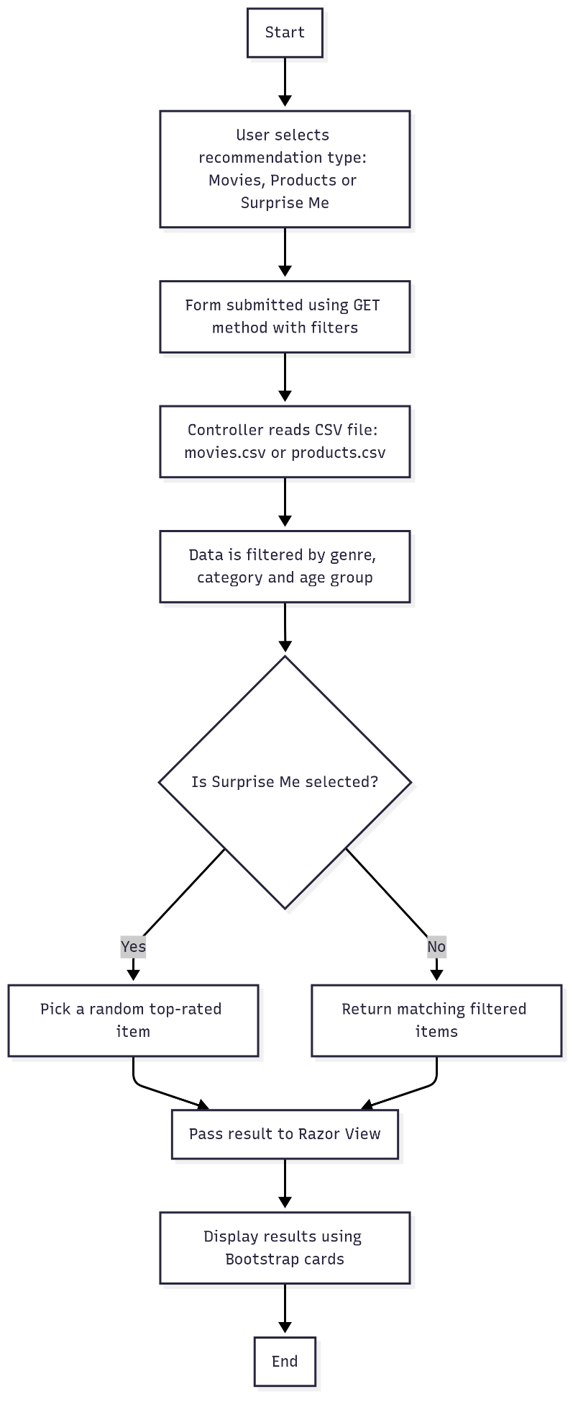

Figure 3.1:Flowchart

Algorithm:

Step 1: Start

Step 2: Display Recommendation Options
- Show three main options on the homepage:
- Movie Recommendation
- Product Recommendation\
- Surprise Me
Step 3: User Selects a Type
- Navigate to the selected page (Movies, Products, or Surprise)
- Display dropdown filters: genre/category and age (New/Old)
Step 4: Handle Form Submission
- On clicking "Get Recommendation", the form sends a GET request to the appropriate controller
Step 5: Load Data from CSV
- Read the corresponding CSV file (movies.csv or products.csv) using StreamReader or CSV parser
- Parse each row into a list of objects (Movie or Product model)
Step 6: Apply Filter Logic
- Filter the loaded list based on selected genre/category and age group
- If "Surprise Me", skip filters and select a random top-rated item

Step 7: Pass Data to View
- Send the filtered or random result list to the Razor View
- Use View(model) to bind the results to the frontend
Step 8: Display Results
- In Razor View, loop through the result list and render each item as a Bootstrap card
(Show: Title, Genre, Rating, Image, etc.)
Step 9: Error Handling
- If no filters are selected or results are empty, show a friendly error message
- Handle file read errors, invalid CSV rows, or missing images gracefully
Step 10: End

CHAPTER 4.
RESULTS ANALYSIS AND VALIDATION

4.1. Implementation of Solution

The implementation of the RecoBox Recommendation System involved careful integration of front-end design, server-side logic, and data handling using .csv files. The development process was divided into structured phases to ensure modularity, reusability, and responsiveness, all while aligning with academic project constraints.

Use of Modern Tools:
- Development Environment
- Visual Studio 2022: Used for creating the ASP.NET Core MVC web application with Razor Pages.
- .NET 6 SDK: Provided the runtime for the MVC framework and C# backend logic.
- Data Management
- CSV Files: Movie and product data were stored and maintained in .csv files, allowing easy updates without code modification.
- CSV Reader: C# logic using StreamReader and LINQ was written to parse and filter the data in real-time during form submission.
- UI/UX Design
- Bootstrap 5: Used for responsive layout, card-based displays, and mobile-first design.
- Google Fonts & Custom Styling: Added for aesthetic consistency and readability.
- Sticky Footer and Hover Effects: Ensured polished, modern navigation and layout.

- Design & Visualization Tools
- Lucidchart / Mermaid Editor: Used to create flowcharts and diagrams for implementation methodology.
- Tldraw (optional): Assisted in visualizing logic blocks for forms and interaction design.
- Report Preparation
- MS Word & Canva: Used for report formatting, embedding screenshots, and flow diagrams.
- Mermaid.live: Used for generating clean technical diagrams for the flow of execution.
- Testing / Debugging / Validation
- Manual testing was performed for:
- Filter logic (correct results for selected genre and age).
- UI responsiveness on different screen sizes.
- Randomization accuracy in the Surprise Me module.
- Exception handling for invalid filter states and missing files.
- CSV parsing was validated against edge cases (blank fields, malformed rows).
Razor View rendering was tested for all filter paths (e.g., no match found, multiple results).

Outcome:
The final system successfully meets the objective of delivering fast, accurate, and customizable recommendations.
Users can:
- Choose filters and instantly get relevant movies or products.
- Enjoy a fully responsive layout.
- Use the Surprise Me feature to randomly discover content.
The use of CSV files in combination with ASP.NET Core MVC ensured that the solution remained lightweight, modular, and easy to demonstrate in an academic or training environment.

4.2. Output Screenshots

The following screenshots demonstrate the functionality, responsiveness, and layout of the RecoBox Recommendation System across different modules. Each interface was tested on desktop and mobile viewports to ensure visual consistency and interactivity.

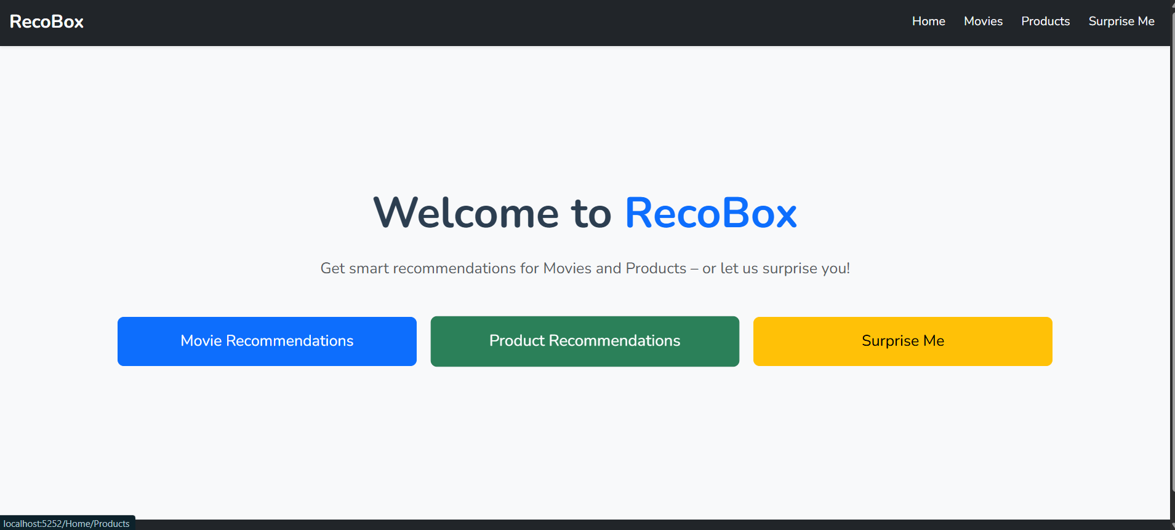

Figure 4.1: Home Page – Recommendation Type Selection

Description: This is the landing page of RecoBox, where users can select between “Movie Recommendations,” “Product Recommendations,” or “Surprise Me.” The layout uses Bootstrap with centered buttons and a clean navbar for easy navigation.

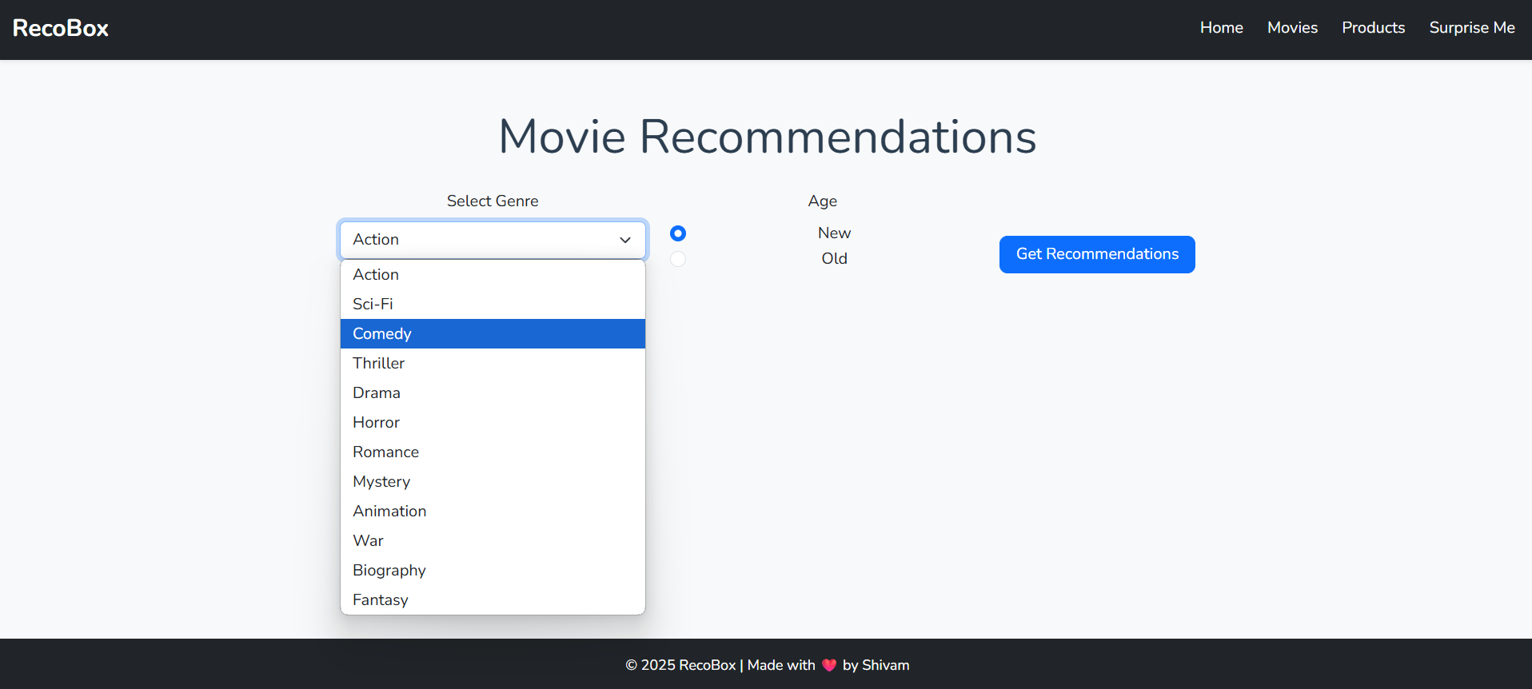

Figure 4.2: Movies Page – Filter Form and Results

Description: After selecting "Movies", users are presented with a filter form containing dropdowns for genre and age (New or Old). Upon submission, the filtered results are displayed as responsive cards with titles, genre, rating, and images.

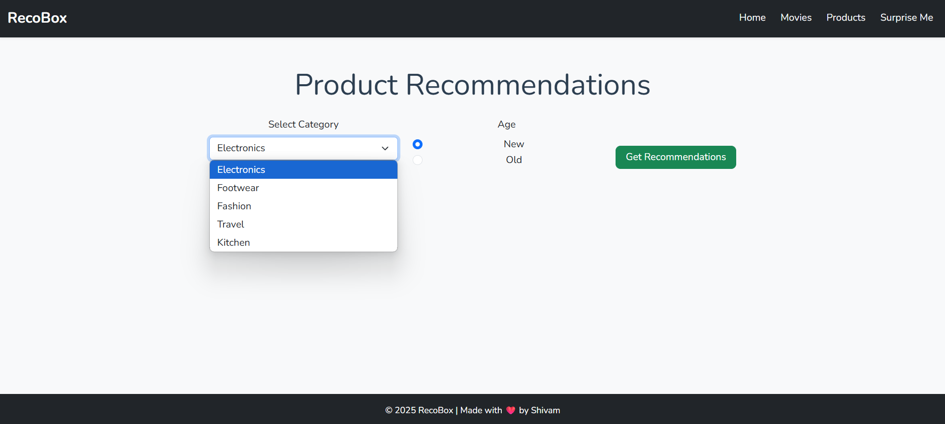

Figure 4.3: Products Page – Category Filtering

Description: Similar to the Movies page, the Products module displays a dropdown-based filter form. Once submitted, relevant product cards are shown based on the user’s selections.

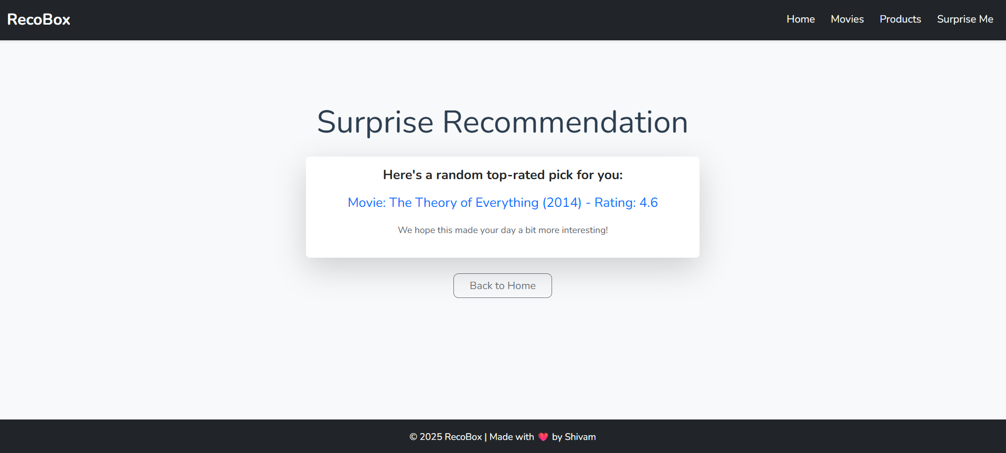

Figure 4.4: Surprise Me – Random Result Display

Description: The “Surprise Me” feature selects a random item from the dataset (movie or product). The selected result is presented on a standalone page with a card layout showing its details.

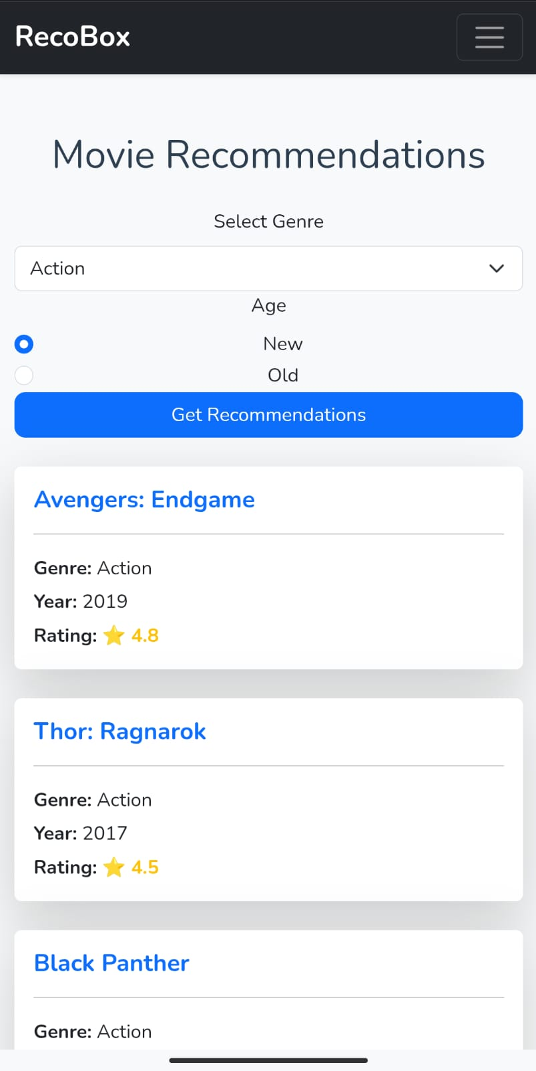

Figure 4.5: RecoBox on Mobile Device

Description: This screenshot shows RecoBox running on a mobile device via IP access (http://192.168.1.5:5252). It confirms responsive layout, working filter functionality, and Bootstrap cards rendering correctly on smaller screens.

CHAPTER 5.
CONCLUSION AND FUTURE WORK

5.1. Conclusion

The RecoBox Recommendation System was successfully developed using ASP.NET Core MVC and demonstrates the ability to provide personalized movie and product suggestions based on user-selected filters. The application relies on CSV-based data sources and incorporates form filtering, Razor views, and Bootstrap for responsive front-end presentation. A “Surprise Me” feature adds a randomized exploration element, making the experience more engaging.

Expected Outcome:

Provide recommendations based on filters like genre/category and age group

Offer a clean and responsive interface accessible across devices

Enable a “Surprise Me” mode for random top-rated item discovery

Maintain flexibility and ease of data updates via CSV instead of database

Ensure functional operation on both desktop and mobile browsers

Achieved Outcome:

Filter-based recommendations worked accurately for both movies and products

Razor Views successfully rendered dynamic data from CSV files

Surprise Me logic correctly displayed randomized selections

UI remained responsive and visually consistent on multiple screen sizes

Mobile access via IP hosting was implemented and verified
.

Deviation from Expected Results:

Initial form filtering had issues persisting data between GET requests

Duplicate entries could appear if CSV rows had similar names but varied ratings

No user login system to track history or personalize deeply.

Reasons for Deviation:

The system uses basic in-memory filtering without session storage or state management

CSV files lack relational structure, so cross-filtering logic is limited

Login and user tracking were excluded from scope to keep the project lightweight for demo/training purposes.

Overall Conclusion:

RecoBox successfully met its core objectives by offering a web-based recommendation experience with a simple interface, accurate results, and lightweight data handling. Despite minor limitations such as lack of database and personalization, the system performs reliably across both desktop and mobile environments. It serves as a strong foundation for further expansion into full-fledged intelligent recommendation systems using databases, ML-based models, or user history analytics..

5.2. Future Work

While RecoBox fulfills its primary objective of delivering effective movie and product recommendations using CSV data and form filters, there is significant scope for future enhancement. These additions would not only improve user experience but also make the system scalable, intelligent, and ready for production-level deployment.

- Database Integration (Replace CSVs)
At present, the system relies on static .csv files to store and retrieve movie and product data. While this approach is simple and sufficient for prototypes or small datasets, it becomes inefficient as data grows. Migrating to a proper database system such as SQL Server, PostgreSQL, or MongoDB would allow dynamic data management. With a database backend, developers can implement real-time updates, efficiently store relational data, and perform optimized queries. It also allows future integration with admin dashboards and analytics tools, making the system more maintainable and scalable.
- User Authentication and Profiles
RecoBox currently functions as an open-access system without user login or personalization. Implementing authentication would enable the creation of user profiles, which could store preferences, recently viewed items, or custom watchlists. Personalized profiles also open up possibilities for enhanced security, session management, and history-based recommendations, transforming the app into a more interactive and user-specific platform.
- AI-Based Recommendation Engine
Currently, recommendation logic is based purely on manual filters applied to static data. Future development can include AI-powered models such as collaborative filtering, content-based filtering, or hybrid approaches that use machine learning. These models would be able to learn from user behavior and preferences, providing smarter and more relevant suggestions that go beyond simple filter-matching logic.
- Mobile Application Version
To make RecoBox more accessible and convenient, developing a cross-platform mobile application would be highly beneficial. A mobile app built using Flutter, React Native, or MAUI would allow users to interact with the recommendation system anytime, anywhere. It would also support features like offline browsing or camera-based product scanning, further expanding the app’s use cases.
- Cloud Hosting and Deployment
Deploying the application on cloud platforms like Microsoft Azure, AWS, or Vercel would make it publicly accessible and easier to maintain. Cloud deployment also enables automatic scaling based on traffic, integration with cloud databases or storage, and the ability to run background services or APIs for future microservice-based architecture.
- Multi-language and Multi-region Support
The current interface and dataset are limited to English-language items. Expanding RecoBox to support multiple languages and regional preferences would make it suitable for a global audience. This could include filtering by international movie industries (e.g., Bollywood, K-dramas) or country-specific product catalogs, increasing its adaptability and reach.

- Security and Access Control
As user data and backend capabilities increase, securing the application becomes essential. Future enhancements should include HTTPS support, encrypted user sessions, input validation, and role-based access controls. These measures will ensure that both users and administrators interact with the platform in a safe and secure manner.
- Feedback and Rating System
Incorporating a feedback loop would allow users to rate the recommendations they receive or provide comments on their usefulness. This data can be used to fine-tune future recommendations, add popularity rankings, or even train machine learning models for more accurate suggestions.
- Admin Dashboard for Data Management
An admin panel would give project maintainers or business users a convenient interface to manage the CSV or database content. This dashboard could allow them to add, edit, or remove products and movies, view usage statistics, monitor errors, and manage user reports — all without needing to access or edit raw data files manually.
.

REFERENCES

- Microsoft. (n.d.). ASP.NET Core Documentation. Retrieved from:
https://learn.microsoft.com/en-us/aspnet/core
- Microsoft. (n.d.). Working with Razor Pages in ASP.NET Core. Retrieved from:
https://learn.microsoft.com/en-us/aspnet/core/razor-pages/
- Bootstrap Team. (n.d.). Bootstrap 5 Documentation. Retrieved from:
https://getbootstrap.com/docs/5.0/getting-started/introduction/
- CsvHelper. (n.d.). Official GitHub Repository. Retrieved from:
https://github.com/JoshClose/CsvHelper
- Stack Overflow Contributors. (n.d.). Filtering Data in C# using LINQ. Retrieved from:
https://stackoverflow.com
- .NET Foundation. (n.d.). Introduction to Model-View-Controller (MVC) Architecture. Retrieved from:
https://dotnet.microsoft.com/en-us/learn/aspnet/mvc
- Microsoft. (n.d.). Using StreamReader in C#. Retrieved from:
https://learn.microsoft.com/en-us/dotnet/api/system.io.streamreader
- GitHub. (n.d.). ASP.NET Core MVC Sample Projects and Repositories. Retrieved from:
https://github.com/dotnet/aspnetcore
- Vercel. (n.d.). Vercel Hosting for ASP.NET & Frontend Apps. Retrieved from:
https://vercel.com

